  Founded 1971 | Suburban Football League  43rd Season – 2013-2014 | Bulletin  39
 | Suburban Football League  43rd Season – 2013-2014 | 26 April  2014

President  D.J.F.Alldridge MBE  Chairman  John Young  Chief Executive  Mike Bidmead  Vice Chairman  Graham Starns  Minutes Secretary  Geoff Ellis  Finance & Communications Manager  Graham Prentice  Fixture Manager Tony King  Referees Manager  Mike Castle  Assistant Referees  Manager  Tony King  Registrations Manager  Val Bidmead  Bulletin Editor Geoff Ellis |   All the latest details regarding fixtures, results, league tables, leading goal scorers, match officials and more are available now on football.mitoo. Please bookmark this web address:  Note: change of link: football.mitoo.co/News.cfm?LeagueCode=SUB2013  League Notices  Unavailable Club Official(s)  Lingfield FC - Katie Lancashire unavailable from 15th April to the 2nd May 2014 inclusive  In her absence contact: Pam Tomsett (details as per handbook)  Newport Pagnell Town - Club Secretary: Pauline Wooldridge unavailable until 8 May 2014  In her absence please contact: Steve Handley (details as per Handbook)  Change of Club Secretary:  Dorking Wanderers  Becky Fleming, Flat 1, Meadvale Court, 104 Somerset Road, Redhill, Surrey RH1 6LR  Tel: 07889 751566; email: beckysecretary@dorkingwanderersfc.com
  
  Congratulations to . . .
  Premier Division Champions: SUTTON UNITED FC
  Central Division Champions: UXBRIDGE FC
  Suburban League Challenge Cup Winner: SUTTON UNITED FC
  Suburban League Champions Cup Winner: SUTTON UNITED FC
  Surrey Premier Cup Winners: METROPOLITAN POLICE FC
  ANNUAL PRESENTATION DINNER
  Saturday 24th May 2014 . 6.00 for 6.30 pm
  COPPID BEECH HOTEL, BRACKNELL, BERKSHIRE
  TICKET £32.50 (available from Tony King)
  Guest Speaker: Peter Brackley
  Musical Entertainment by Rob Tidbury, Singer and Performer

Clubs are respectfully reminded that
“TELEPHONE CALLS” to LEAGUE OFFICERS
are to be:
AFTER 9.30 am of a morning and BEFORE 10.00 pm of an Evening
Michael Bidmead, Chief Executive

www.football.mitoo.co.uk Results Hotline: 0800 0 727 833
PHONING RESULTS (including postponements)
Please remember to telephone in your match result/postponements
to the dedicated
0800 0 727 833 phone line
***** Don’t forget to phone in your COUNTY CUP RESULTS too *****
Results . . .

Tuesday 22nd April 2014
Premier Division
Bromley 1-4 Met Police
Carshalton Athletic 3-3 Corinthian-Casuals
Central Division
Chessington & Hook United P-P Frimley Green
Farnham Town P-P North Greenford United
Hanworth Villa 3-0 Camberley Town
Knaphill 3-4 Hartley Wintney
Westfield P-P Tooting & Mitcham United
North Division
Dunstable Town 1-4 Tring Athletic
South Division
Chichester City P-P Lingfield

Wednesday 23rd April 2014
South Division
Lordswood 4-0 Horsham YMCA

Thursday 24th April 2014
Suburban Challenge Cup Final at Met Police FC
Sutton United 4-1 Welling United
Premier Division
Bromley 0-1 Hampton & Richmond Borough
Central Division
Chessington & Hook United P-P Westfield
Frimley Green 4-3 Molesey
North Division
Barton Rovers 4-1 Southall
South Division
Lingfield 2-7 Erith Town

Saturday 26th April 2014
Premier Division
Hampton & Richmond Boro 1-0 Corinthian-Casuals
Met Police 1-4 Boreham Wood
Sutton United 0-0 Carshalton Athletic
Central Division
Camberley Town 2-1 Westfield
Frimley Green 2-4 Chessington & Hook United
Hanworth Villa 1-4 North Greenford United
Molesey 3-3 Hartley Wintney
Uxbridge 2-0 Tooting & Mitcham United
North Division
Berkhamsted 4-1 Harefield United
Royston Town 10-0 Newport Pagnell Town
South Division
Chichester City 1-6 Corinthian
Dorking Wanderers 2-3 Horsham YMCA
Lingfield 0-3 Raynes Park Vale
Phoenix Sports 3-1 East Grinstead Town
South Park P-P Erith Town

Additional/Changes to Fixtures shown in Red

www.football.mitoo.co.uk Results Hotline: 0800 0 727 833
League Tables . . .
Suburban Football League - 2013-2014 Season
Premier Division P W D L F A GD Pts
1 SUTTON UNITED 18 14 2 2 42 15 27 44
2 Welling United 18 12 0 6 42 37 5 36
3 Woking 18 11 1 6 63 33 30 34
4 Boreham Wood 18 9 2 7 42 31 11 29
5 Metropolitan Police 18 8 4 6 46 34 12 28
6 Tonbridge Angels 18 7 3 8 29 34 -5 24
7 Corinthian-Casuals 18 5 4 9 28 39 -11 19
8 Bromley 17 4 3 10 18 49 -31 15
9 Hampton & Richmond Borough 18 4 2 12 18 41 -23 14
10 Carshalton Athletic 17 3 3 11 22 37 -15 12

Central Division P W D L F A GD Pts
1 UXBRIDGE 26 21 2 3 93 28 65 65
2 Tooting & Mitcham United 23 16 5 2 79 21 58 53
3 Hartley Wintney 24 15 3 6 68 44 24 48
4 Walton & Hersham 24 14 5 5 45 28 17 47
5 North Greenford United 24 14 3 7 73 35 38 45
6 Westfield 24 11 2 11 69 55 14 35
7 Camberley Town 24 10 4 10 42 52 -10 34
8 Hanworth Villa 25 10 3 12 56 66 -10 33
9 Farnham Town 25 8 6 11 50 54 -4 30
10 Ashford Town (Middlesex) 26 8 4 14 38 60 -22 28
11 Chessington & Hook United 22 9 1 12 49 72 -23 28
12 Molesey 26 6 4 16 46 68 -22 22
13 Knaphill 26 4 4 18 35 86 -51 16
14 Frimley Green 25 3 0 22 29 103 -74 9
The playing record of Cobham has been expunged

North Division P W D L F A GD Pts
1 Tring Athletic 18 11 3 4 44 22 22 36
2 Barton Rovers 18 10 3 5 43 25 18 33
3 Dunstable Town 17 9 3 5 35 25 10 30
4 Royston Town 15 8 3 4 35 27 8 27
5 Leighton Town 17 8 2 7 27 32 -5 26
6 Northwood 17 6 5 6 26 25 1 23
7 Newport Pagnell Town 18 6 4 8 27 44 -17 22
8 Berkhamsted 18 4 3 11 29 36 -7 15
9 Harefield United 17 3 6 8 29 46 -17 15
10 Southall 17 2 6 9 28 41 -13 12

South Division P W D L F A GD Pts
1 Phoenix Sports 20 13 4 3 54 24 30 43
2 Corinthian 19 13 2 4 74 30 44 41
3 Erith Town 19 11 3 5 41 22 19 36
4 Raynes Park Vale 19 9 7 3 48 32 16 34
5 Horsham YMCA 20 8 4 8 44 51 -7 28
6 East Grinstead Town 20 8 1 11 41 40 1 25
7 Lordswood 18 6 6 6 32 26 6 24
8 South Park 18 5 7 6 35 42 -7 22
9 Chichester City 17 3 5 9 29 46 -17 14
11 Dorking Wanderers 18 4 2 12 34 57 -23 14
12 Lingfield 18 2 1 15 18 80 -62 7
Lingfield v Dorking Wanderers - Home Win was awarded
Lordswood v East Grinstead Town - Home Win was awarded
The playing records of Horley Town & Redhill have been expunged

www.football.mitoo.co.uk Results Hotline: 0800 0 727 833
Fixtures . . . Referee Asst Ref Asst Ref * Joint Travel
Monday 28th April 2014
Central Division
Chessington & Hook United v Westfield B Shelley (51) 233 S Matthews 144 G Kehoe
Walton & Hersham v Hanworth Villa L Hertimage (28) 129 D Goater* 196 H Wellington*

Tuesday 29th April 2014
Central Division
Tooting & Mitcham United v Camberley Town M Westlake (62) 117 D Cooper 152 K Murray
North Division
Royston Town v Northwood J Was (60) 127 D French* 181 R Wakefield*
Suburban Challenge Shield Quarter Final
Hartley Wintney v Sutton United D Snaith (54) 105 T Beard 148 M Langley

Wednesday 30th April 2014
South Division
Dorking Wanderers v Corinthian G Marley (35) 158 B Reader 144 G Kehoe

Thursday 1st May 2014
Central Division
Chessington & Hook United v Hartley Wintney S Elson (16) 162 P Savva 135 I Hempel
North Greenford United v Walton & Hersham C Smith (53) 111 W Boyle 195 I Bath
North Division
Leighton Town v Dunstable Town J.Redmond (44) 181 R Wakefield 127 D French

Saturday 3rd May 2014
Premier Division
Bromley v Carshalton Athletic T Gilmore (20) 135 I Hempel 195 T Beard
to be played at Carshalton Athletic FC
Central Division
Chessington & Hook United v Camberley Town C Hartley (26) 127 D French 161 B Rowland
Tooting & Mitcham United v Hartley Wintney S Hart (25) 154 M Olver 162 P Savva
North Division
Royston Town v Southall A Rafique (42) 121 L Deschamps 171 E Stone
South Division
Chichester City v South Park K Howard (29) 144 G Kehoe 137 A Hodge
Lordswood v Dorking Wanderers B Lynch (34) 221 M Cook 158 L Randall

Wednesday 7th May 2014
Central Division
Westfield v Tooting & Mitcham United D Belbin (4) 129 D Goater 145 A King

Games Outstanding and to be arranged by Fixture Manager
North Division
Royston Town v Harefield United
Awaiting a Management Committee Decision

Shield Quarter Final
Royston Town v Welling United
Shield Semi Final & Final

Additional/Changes to Fixtures/Match Officials shown in Red

www.football.mitoo.co.uk Results Hotline: 0800 0 727 833

Suburban Football League
43rd Season – 2013-2014
ANNUAL
PRESENTATION DINNER
Saturday 24th May 2014 . 6.00 for 6.30 pm
COPPID BEECH HOTEL
BRACKNELL, BERKSHIRE
TICKET £32.50 (available from Tony King)
Guest Speaker: Peter Brackley
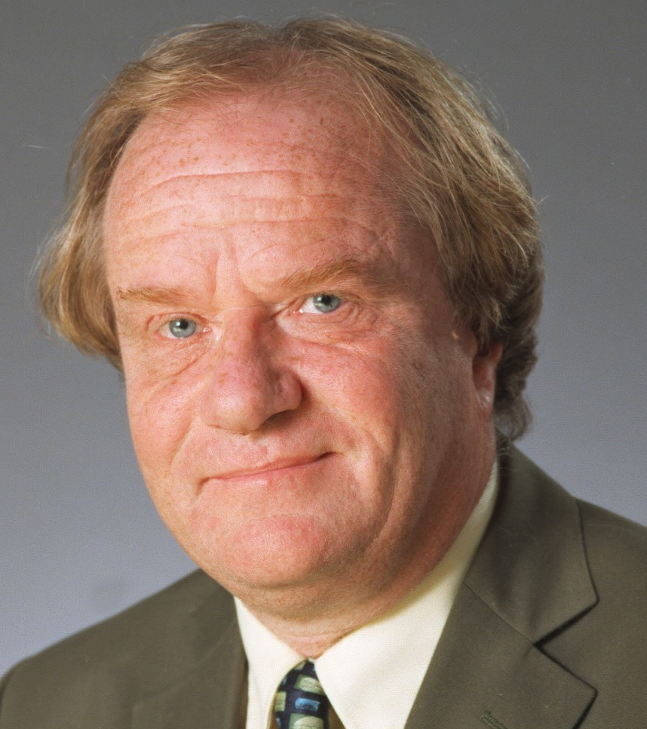
"World Cup, European Championship, FA Cup and Football Italia commentator.
Peter is one of the country's most experienced football commentators, having worked on finals for the World Cup, EuropeanChampionship, FA Cup and League Cup. He commentated for the ITV Network on The Premiership and was a regular contributor to its football magazine programme On The Ball.
Peter began his broadcasting career in local radio before moving to BBC Radio in the late 1970s. In 1982 he joined Central Television as a football commentator and since then has worked for many of the ITV regional companies as well as the ITV network. Peter was also the voice of Channel 4's coverage of Italy's Serie A for ten years and in the 2005/06 season he was the main commentator on Bravo'sFootball Italia Live.
Away from his sports broadcasting, Peter used his natural comic talent and gift for impressions on the after dinner circuit for many years, including a tour with George Best and Rodney Marsh which included a run at the London Palladium. He now prefers to devote his entertainment skills to radio shows and voice-overs for computer games and commercials.
Peter is a lifelong Brighton & Hove Albion supporter!
Aaron Bliss of Word Press.com say:
"PETER BRACKLEY
A giant among commentators, my initial experiences of Brackley were on the Channel 4 Serie ‘A’ coverage of the mid-90s. He combines the oak-aged, venerable tone associated with esteemed veterans like Brian Moore and Barry Davies, with the loquacious edge of an Ian Darke. A glittering vocabulary and exemplary delivery with no pompous air at all makes Brackley the stand-out candidate in this list, surpassing even Tyler in expertise and aura.
Most likely to be: The best around.
Most likely to say: “Wha-at a goal. An astounding finish from Vieri!”
Finest hour?"

Musical Entertainment by Rob Tidbury, Singer and Performer

