  Founded 1971 | Suburban Football League  43rd Season – 2013-2014 | Bulletin  40
 | Suburban Football League  43rd Season – 2013-2014 | 4 May  2014

President  D.J.F.Alldridge MBE  Chairman  John Young  Chief Executive  Mike Bidmead  Vice Chairman  Graham Starns  Minutes Secretary  Geoff Ellis  Finance & Communications Manager  Graham Prentice  Fixture Manager Tony King  Referees Manager  Mike Castle  Assistant Referees  Manager  Tony King  Registrations Manager  Val Bidmead  Bulletin Editor Geoff Ellis |   All the latest details regarding fixtures, results, league tables, leading goal scorers, match officials and more are available now on football.mitoo. Please bookmark this web address:  Note: change of link: football.mitoo.co/News.cfm?LeagueCode=SUB2013  League Notices  Unavailable Club Official(s)  Newport Pagnell Town - Club Secretary: Pauline Wooldridge unavailable until 8 May 2014  In her absence please contact: Steve Handley (details as per Handbook)  Change of Club Secretary:  Dorking Wanderers  Becky Fleming, Flat 1, Meadvale Court, 104 Somerset Road, Redhill, Surrey RH1 6LR  Tel: 07889 751566; email: beckysecretary@dorkingwanderersfc.com
  
  Congratulations to . . .
  Premier Division Champions: SUTTON UNITED FC
  Runners-up: Welling United FC
  Central Division Champions: UXBRIDGE FC
  Runners-up: Tooting & Mitcham United FC
  North Division Champions: TBA
  Runners-up: TBA
  South Division Champions: CORINTHIAN FC
  Runners-up: Phoenix Sports FC
  Suburban League Challenge Cup Winner: SUTTON UNITED FC
  Runners-up: Welling United FC
  Suburban League Champions Cup Winner: SUTTON UNITED FC
  Runners-up: Metropolitan Police FC
  COUNTY CUPS
  Surrey Premier Cup Winners: METROPOLITAN POLICE FC
  Congratulations to the following Referees’ on being promoted to Level 4, and wish them well in their refereeing career:
  Ronald Albert, John Fowler, Carl Smith,
  Mark Edwards, Tom Harkin, Stan Stoyanov
  Shelby Elson, Michael Mackey, Jonathan Was
  & Piotr Zachwieja

Clubs are respectfully reminded that
“TELEPHONE CALLS” to LEAGUE OFFICERS
are to be:
AFTER 9.30 am of a morning and BEFORE 10.00 pm of an Evening
Michael Bidmead, Chief Executive

www.football.mitoo.co.uk Results Hotline: 0800 0 727 833
PHONING RESULTS (including postponements)
Please remember to telephone in your match result/postponements
to the dedicated
0800 0 727 833 phone line
***** Don’t forget to phone in your COUNTY CUP RESULTS too *****
Results . . .
Thursday 1st May 2014
Central Division
Chessington & Hook United P-P Hartley Wintney
North Greenford United 5-2 Walton & Hersham
North Division
Leighton Town 0-6 Dunstable Town

Saturday 3rd May 2014
Premier Division
Bromley 0-1 Carshalton Athletic
Central Division
Chessington & Hook United 0-2 Camberley Town
Tooting & Mitcham United 5-3 Hartley Wintney
North Division
Royston Town 4-0 Southall
South Division
Chichester City 1-3 South Park
Lordswood 4-0 Dorking Wanderers

Correction
Saturday 26th April 2014
Central Division
Hanworth Villa 1-3 North Greenford United

Monday 28th April 2014
Central Division
Chessington & Hook United 3-5 Westfield
Walton & Hersham P-P Hanworth Villa

Tuesday 29th April 2014
Central Division
Tooting & Mitcham United 8-2 Camberley Town
North Division
Royston Town 11-0 Northwood
Suburban Challenge Shield Quarter Final
Hartley Wintney P-P Sutton United

Wednesday 30th April 2014
South Division
Dorking Wanderers 0-8 Corinthian

Additional/Changes to Fixtures shown in Red

Fixtures . . . Referee Asst Ref Asst Ref * Joint Travel
Tuesday 6th May 2014
Central Division
Chessington & Hook United v Hartley Wintney S Elson (16) 137 A Hodge 135 I Hempel
North Division
Royston Town v Harefield United TBA 123 D Elkins 213 N Howard

Wednesday 7th May 2014
Central Division
Westfield v Tooting & Mitcham United D Belbin (4) 129 D Goater 117 D Cooper

Thursday 7th May 2014
Central Division
Farnham Town v North Greenford United TBA 105 T Beard 172 P Sturrock

Saturday 10th May 2014
Suburban Challenge Shield Quarter Final
Royston Town v Welling United TBA 127 D French 169 M Stewart
Suburban Challenge Shield Semi Final
Berkhamsted v Tonbridge Angels TBA 185 R Wheeler 147 B Kyriacou

Games Outstanding and to be arranged by Fixture Manager
Shield Quarter Final
Hartley Wintney v Sutton United
awaiting a date

Additional/Changes to Fixtures/Match Officials shown in Red

www.football.mitoo.co.uk Results Hotline: 0800 0 727 833
League Tables . . .
Suburban Football League - 2013-2014 Season
Premier Division P W D L F A GD Pts
1 SUTTON UNITED 18 14 2 2 42 15 27 44
2 Welling United 18 12 0 6 42 37 5 36
3 Woking 18 11 1 6 63 33 30 34
4 Boreham Wood 18 9 2 7 42 31 11 29
5 Metropolitan Police 18 8 4 6 46 34 12 28
6 Tonbridge Angels 18 7 3 8 29 34 -5 24
7 Corinthian-Casuals 18 5 4 9 28 39 -11 19
8 Carshalton Athletic 18 4 3 11 23 37 -14 15
9 Bromley 18 4 3 11 18 50 -32 15
10 Hampton & Richmond Borough 18 4 2 12 18 41 -23 14

Central Division P W D L F A GD Pts
1 UXBRIDGE 26 21 2 3 93 28 65 65
2 Tooting & Mitcham United 25 18 5 2 92 26 66 59
3 North Greenford United 25 15 3 7 77 37 40 48
4 Hartley Wintney 25 15 3 7 71 49 22 48
5 Walton & Hersham 26 14 6 6 47 33 14 48
6 Westfield 25 12 2 11 74 58 16 38
7 Camberley Town 26 11 4 11 46 60 -14 37
8 Hanworth Villa 26 10 4 12 56 65 -9 34
9 Farnham Town 25 8 6 11 50 54 -4 30
10 Ashford Town (Middlesex) 26 8 4 14 38 60 -22 28
11 Chessington & Hook United 24 9 1 14 52 79 -27 28
12 Molesey 26 6 4 16 46 68 -22 22
13 Knaphill 26 4 4 18 35 86 -51 16
14 Frimley Green 25 3 0 22 29 103 -74 9
Walton & Hersham v Hanworth Villa - Draw was awarded
The playing record of Cobham has been expunged

North Division P W D L F A GD Pts
1 Tring Athletic 18 11 3 4 44 22 22 36
2 Royston Town 17 10 3 4 50 27 23 33
3 Barton Rovers 18 10 3 5 43 25 18 33
4 Dunstable Town 18 10 3 5 41 25 16 33
5 Leighton Town 18 8 2 8 27 38 -11 26
6 Northwood 18 6 5 7 26 36 -10 23
7 Newport Pagnell Town 18 6 4 8 27 44 -17 22
8 Berkhamsted 18 4 3 11 29 36 -7 15
9 Harefield United 17 3 6 8 29 46 -17 15
10 Southall 18 2 6 10 28 45 -17 12

South Division P W D L F A GD Pts
1 CORINTHIAN 20 14 2 4 82 30 52 44
2 Phoenix Sports 20 13 4 3 54 24 30 43
3 Erith Town 19 11 3 5 41 22 19 36
4 Raynes Park Vale 19 9 7 3 48 32 16 34
5 Horsham YMCA 20 8 4 8 44 51 -7 28
6 Lordswood 19 7 6 6 36 26 10 27
7 East Grinstead Town 20 8 1 11 41 40 1 25
8 South Park 19 6 7 6 38 43 -5 25
9 Chichester City 19 4 5 10 30 49 -19 17
10 Dorking Wanderers 20 4 2 14 34 69 -35 14
11 Lingfield 19 2 1 16 18 80 -62 7
Lingfield v Dorking Wanderers - Home Win was awarded
Lordswood v East Grinstead Town - Home Win was awarded
Chichester City v Lingfield - Home Win was awarded
Lingfield v Dorking Wanderers - Home Win was awarded
Lordswood v East Grinstead Town - Home Win was awarded
The playing records of Horley Town & Redhill have been expunged

www.football.mitoo.co.uk Results Hotline: 0800 0 727 833

Suburban Football League
43rd Season – 2013-2014
ANNUAL
PRESENTATION DINNER
Saturday 24th May 2014 . 6.00 for 6.30 pm
COPPID BEACH HOTEL
BRACKNELL, BERKSHIRE
TICKET £32.50 (available from Tony King)
Guest Speaker: Peter Brackley
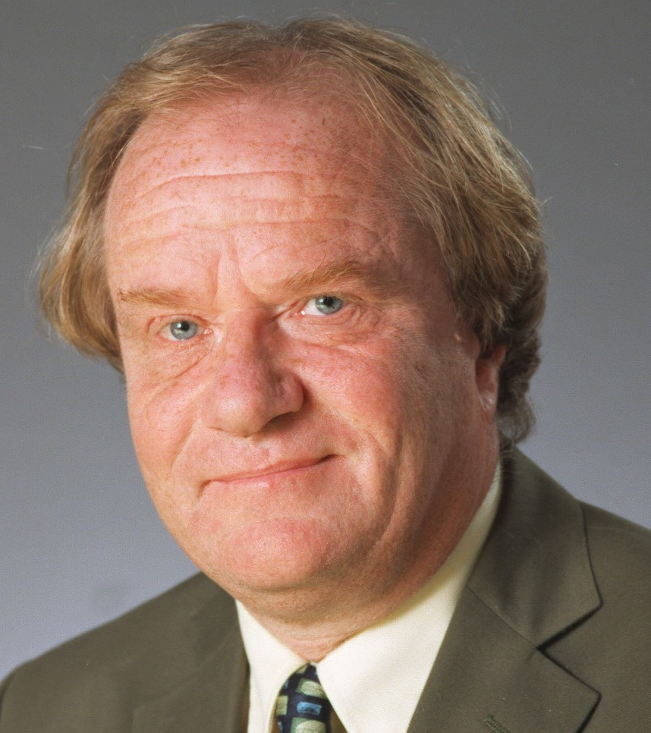
"World Cup, European Championship, FA Cup and Football Italia commentator.
Peter is one of the country's most experienced football commentators, having worked on finals for the World Cup, EuropeanChampionship, FA Cup and League Cup. He commentated for the ITV Network on The Premiership and was a regular contributor to its football magazine programme On The Ball.
Peter began his broadcasting career in local radio before moving to BBC Radio in the late 1970s. In 1982 he joined Central Television as a football commentator and since then has worked for many of the ITV regional companies as well as the ITV network. Peter was also the voice of Channel 4's coverage of Italy's Serie A for ten years and in the 2005/06 season he was the main commentator on Bravo'sFootball Italia Live.
Away from his sports broadcasting, Peter used his natural comic talent and gift for impressions on the after dinner circuit for many years, including a tour with George Best and Rodney Marsh which included a run at the London Palladium. He now prefers to devote his entertainment skills to radio shows and voice-overs for computer games and commercials.
Peter is a lifelong Brighton & Hove Albion supporter!
Aaron Bliss of Word Press.com say:
"PETER BRACKLEY
A giant among commentators, my initial experiences of Brackley were on the Channel 4 Serie ‘A’ coverage of the mid-90s. He combines the oak-aged, venerable tone associated with esteemed veterans like Brian Moore and Barry Davies, with the loquacious edge of an Ian Darke. A glittering vocabulary and exemplary delivery with no pompous air at all makes Brackley the stand-out candidate in this list, surpassing even Tyler in expertise and aura.
Most likely to be: The best around.
Most likely to say: “Wha-at a goal. An astounding finish from Vieri!”
Finest hour?"

Musical Entertainment by Rob Tidbury, Singer and Performer

