  Founded 1971 | Suburban Football League  43rd Season – 2013-2014 | Bulletin  42
 | Suburban Football League  43rd Season – 2013-2014 | 21 May  2014

President  D.J.F.Alldridge MBE  Chairman  John Young  Chief Executive  Mike Bidmead  Vice Chairman  Graham Starns  Minutes Secretary  Geoff Ellis  Finance & Communications Manager  Graham Prentice  Fixture Manager Tony King  Referees Manager  Mike Castle  Assistant Referees  Manager  Tony King  Registrations Manager  Val Bidmead  Bulletin Editor Geoff Ellis |   All the latest details regarding fixtures, results, league tables, leading goal scorers, match officials and more are available now on football.mitoo. Please bookmark this web address:  Note: change of link: football.mitoo.co/News.cfm?LeagueCode=SUB2013  League Notices
  
  Congratulations to . . .
  Premier Division Champions: SUTTON UNITED FC
  Runners-up: Welling United FC
  Central Division Champions: UXBRIDGE FC
  Runners-up: Tooting & Mitcham United FC
  North Division Champions: ROYSTON TOWN FC
  Runners-up: Tring Athletic FC
  South Division Champions: CORINTHIAN FC
  Runners-up: Phoenix Sports FC
  Suburban League Challenge Cup Winner: SUTTON UNITED FC
  Runners-up: Welling United FC
  Suburban League Champions Cup Winner: SUTTON UNITED FC
  Runners-up: Metropolitan Police FC
  Suburban League Challenge Shield Winner: SUTTON UNITED FC
  Runners-up: Tonbridge Angels FC
  COUNTY CUPS
  Surrey Premier Cup Winners: METROPOLITAN POLICE FC
  London Junior Cup Runner-up: Corinthian Casuals FC
  Kent Intermediate Cup Runner-up: Lordswood FC
  Notice is hereby given that the
  ANNUAL GENERAL MEETING
  will be held on
  WEDNESDAY 11 JUNE 2014
  Commencing at 8.00 pm
  at SUTTON UNITED FC
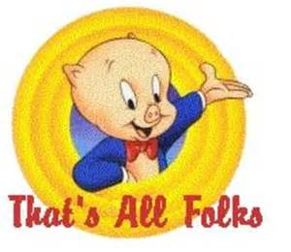
back late July/early August

Clubs are respectfully reminded that
“TELEPHONE CALLS” to LEAGUE OFFICERS
are to be:
AFTER 9.30 am of a morning and BEFORE 10.00 pm of an Evening
Michael Bidmead, Chief Executive

www.football.mitoo.co.uk Results Hotline: 0800 0 727 833
PHONING RESULTS (including postponements)
Please remember to telephone in your match result/postponements
to the dedicated
0800 0 727 833 phone line
***** Don’t forget to phone in your COUNTY CUP RESULTS too *****
Results . . .

Saturday 17th May 2014 Tuesday 20th May 2014
Suburban Challenge Shield Semi Final Suburban Challenge Shield Final
Royston Town 1-3 Sutton United @ Corinthian FC
Tonbridge Angels 1-2aet Sutton United
Final League Tables . . .
Suburban Football League - 2013-2014 Season
Premier Division P W D L F A GD Pts
1 SUTTON UNITED 18 14 2 2 42 15 27 44
2 Welling United 18 12 0 6 42 37 5 36
3 Woking 18 11 1 6 63 33 30 34
4 Boreham Wood 18 9 2 7 42 31 11 29
5 Metropolitan Police 18 8 4 6 46 34 12 28
6 Tonbridge Angels 18 7 3 8 29 34 -5 24
7 Corinthian-Casuals 18 5 4 9 28 39 -11 19
8 Carshalton Athletic 18 4 3 11 23 37 -14 15
9 Bromley 18 4 3 11 18 50 -32 15
10 Hampton & Richmond Borough 18 4 2 12 18 41 -23 14

Central Division P W D L F A GD Pts
1 UXBRIDGE 26 21 2 3 93 28 65 65
2 Tooting & Mitcham United 26 18 5 3 92 26 66 59
3 North Greenford United 26 16 3 7 81 37 44 51
4 Hartley Wintney 26 15 4 7 73 51 22 49
5 Walton & Hersham 26 14 6 6 47 33 14 48
6 Westfield 26 13 2 11 74 58 16 41
7 Camberley Town 26 11 4 11 46 60 -14 37
8 Hanworth Villa 26 10 4 12 56 65 -9 34
9 Farnham Town 26 8 6 12 50 58 -8 30
10 Chessington & Hook United 26 9 3 14 54 81 -27 30
11 Ashford Town (Middlesex) 26 8 4 14 38 60 -22 28
12 Molesey 26 6 4 16 46 68 -22 22
13 Knaphill 26 4 4 18 35 86 -51 16
14 Frimley Green 26 3 1 22 29 103 -74 10

North Division P W D L F A GD Pts
1 ROYSTON TOWN 18 11 3 4 52 27 25 36
2 Tring Athletic 18 11 3 4 44 22 22 36
3 Barton Rovers 18 10 3 5 43 25 18 33
4 Dunstable Town 18 10 3 5 41 25 16 33
5 Leighton Town 18 8 2 8 27 38 -11 26
6 Northwood 18 6 5 7 26 36 -10 23
7 Newport Pagnell Town 18 6 4 8 27 44 -17 22
8 Berkhamsted 18 4 3 11 29 36 -7 15
9 Harefield United 18 3 6 9 29 48 -19 15
10 Southall 18 2 6 10 28 45 -17 12

South Division P W D L F A GD Pts
1 CORINTHIAN 20 14 2 4 82 30 52 44
2 Phoenix Sports 20 13 4 3 54 24 30 43
3 Erith Town 20 11 4 5 41 22 19 37
4 Raynes Park Vale 20 10 7 3 48 32 16 37
5 Lordswood 20 7 7 6 36 26 10 28
6 Horsham YMCA 20 8 4 8 44 51 -7 28
7 South Park 20 6 8 6 38 43 -5 26
8 East Grinstead Town 20 8 1 11 41 40 1 25
9 Chichester City 20 4 5 11 30 49 -19 17
10 Dorking Wanderers 20 4 2 14 34 69 -35 14
11 Lingfield 20 2 2 16 18 80 -62 8
www.football.mitoo.co.uk Results Hotline: 0800 0 727 833

Suburban Football League
43rd Season – 2013-2014
ANNUAL
PRESENTATION DINNER
Saturday 24th May 2014 . 6.00 for 6.30 pm
COPPID BEACH HOTEL
BRACKNELL, BERKSHIRE
TICKET £32.50 (available from Tony King)
Guest Speaker: Peter Brackley
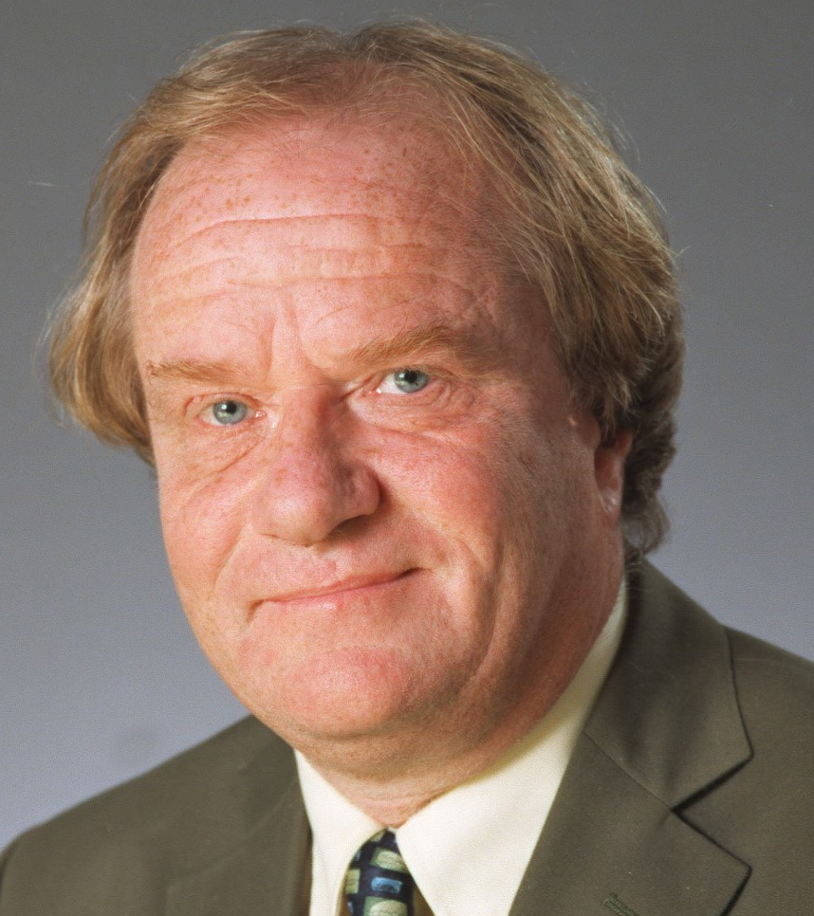
"World Cup, European Championship, FA Cup and Football Italia commentator.
Peter is one of the country's most experienced football commentators, having worked on finals for the World Cup, EuropeanChampionship, FA Cup and League Cup. He commentated for the ITV Network on The Premiership and was a regular contributor to its football magazine programme On The Ball.
Peter began his broadcasting career in local radio before moving to BBC Radio in the late 1970s. In 1982 he joined Central Television as a football commentator and since then has worked for many of the ITV regional companies as well as the ITV network. Peter was also the voice of Channel 4's coverage of Italy's Serie A for ten years and in the 2005/06 season he was the main commentator on Bravo'sFootball Italia Live.
Away from his sports broadcasting, Peter used his natural comic talent and gift for impressions on the after dinner circuit for many years, including a tour with George Best and Rodney Marsh which included a run at the London Palladium. He now prefers to devote his entertainment skills to radio shows and voice-overs for computer games and commercials.
Peter is a lifelong Brighton & Hove Albion supporter!
Aaron Bliss of Word Press.com say:
"PETER BRACKLEY
A giant among commentators, my initial experiences of Brackley were on the Channel 4 Serie ‘A’ coverage of the mid-90s. He combines the oak-aged, venerable tone associated with esteemed veterans like Brian Moore and Barry Davies, with the loquacious edge of an Ian Darke. A glittering vocabulary and exemplary delivery with no pompous air at all makes Brackley the stand-out candidate in this list, surpassing even Tyler in expertise and aura.
Most likely to be: The best around.
Most likely to say: “Wha-at a goal. An astounding finish from Vieri!”
Finest hour?"

Musical Entertainment by Rob Tidbury, Singer and Performer

